Dharmendrasinhji Arts College, Rajkot
Dr. Yagnik Road, Ph./Fax No. (0281) – 2465632
Govt. Of Gujarat
(Affiliated with Saurashtra University)

7.1.5 Green campus initiatives

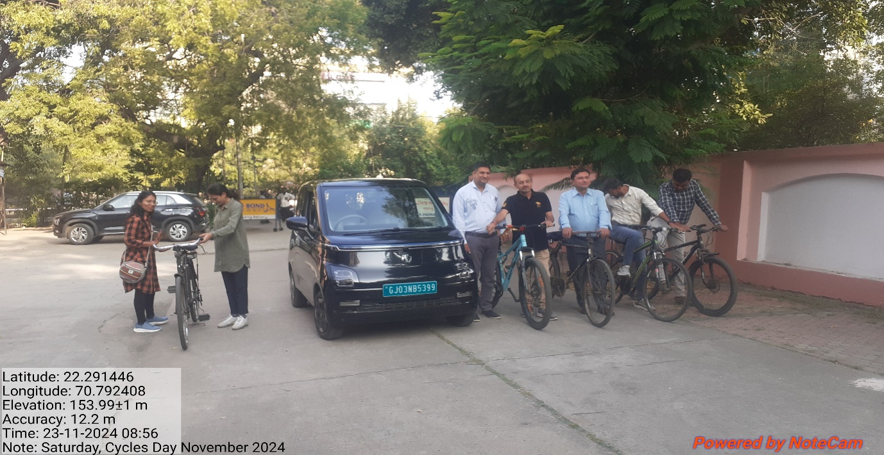
Use of bicycles and E- Bike

Ban on use of plastic
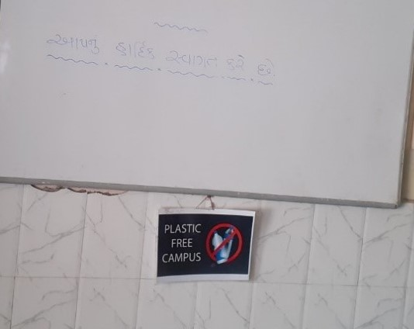

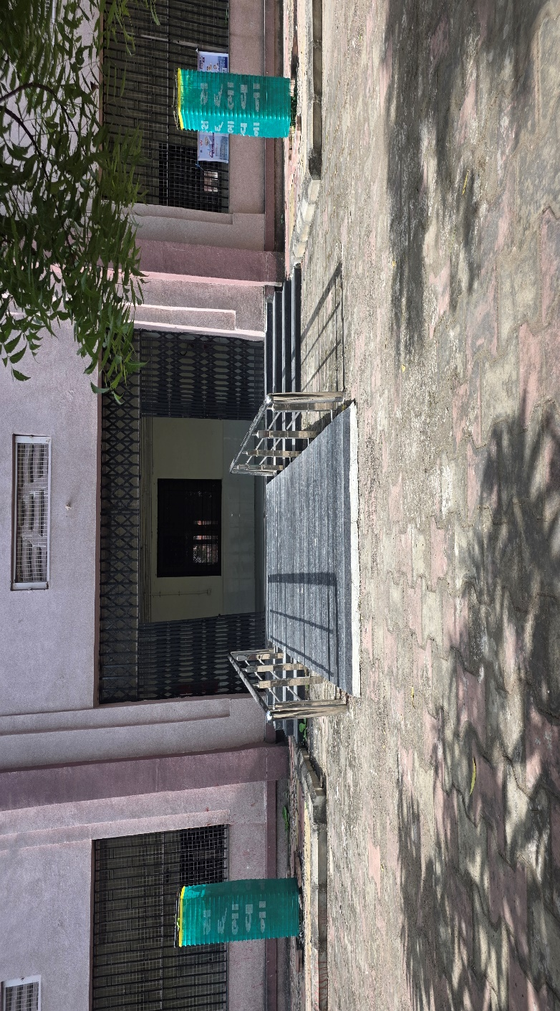

Landscaping

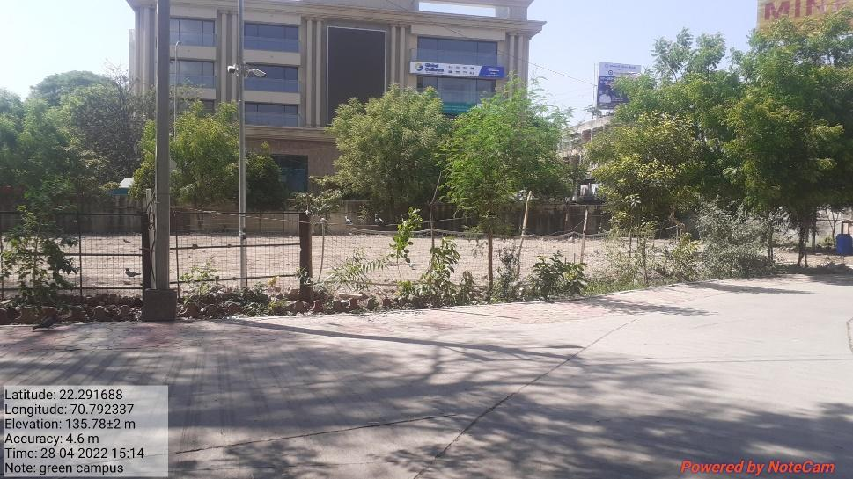
Green Campus and playground

